* 1. **PCB Designing**

**PCB DESIGN SOFTWARE: (DIPTRACE)**

* **FRONTEND**

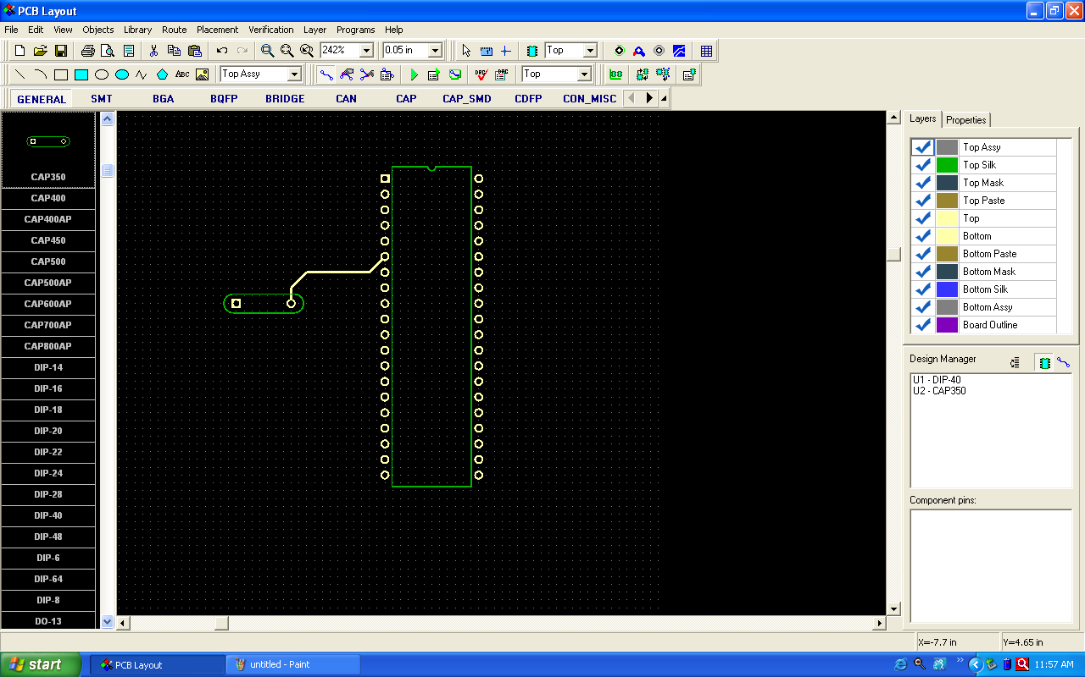

**Fig3.1.1: DIPTRACE COMPLETE PCB DESIGN SYSTEM**

**1**. PCB Layout - PCB design with easy to use manual routing tools and auto router.

**2**. Schematic - creates schematic and exports net list to PCB.

**3.** COM Edit - pattern editor.

**4.** Scheme Edit - component editor. Draw parts and attach patterns to them.

Diptrace provides the following features:

**Easy to learn user interface –**

To design a schematic, simply select and place components onto your document and connect them together using the wire and bus tools. Multisheet design is supported. Then select the menu option 'Switch to Board' to convert the schematic to PCB. Layout can be updated from Schematic in a few clicks at any time. When you create or edit design objects they are highlighted to improve your work. Step-by-step tutorial available from web-site guides you through the design process and allows to get started with ease.

* **PCB Layout:**

**Fig3.1.2: PCB Layout**

**Software development:**

MPLAB X IDE is a software program that runs on a PC (Windows®, Mac OS®, Linux®) to develop applications for Microchip microcontrollers and digital signal controllers. It is called an Integrated Development Environment (IDE), because it provides a single integrated "environment" to develop code for embedded microcontrollers.

MPLAB X Integrated Development Environment brings many changes to the PIC® microcontroller development tool chain. Unlike previous versions of the MPLAB IDE which were developed completely in-house, MPLAB X IDE is based on the open source NetBeans IDE from Oracle. Taking this path has allowed us to add many frequently requested features very quickly and easily, while also providing us with a much more extensible architecture to bring you even more new features in the future.

1. **Open MPLAB IDE v8.56**
2. **From the 'Projects' tab, select the first option 'Project Wizard'**
3. **Click on 'Next' in the welcome window that appears.**
4. **Select the desired PIC which you need to program or build your project on and click on 'Next'**
5. **Select the active tool suite you require; among the list of tool suites given (Usually the HI-TECH Universal tool suite is preferred,if installed)**
6. **Check if the ToolSuite contents listed contains a compiler suiting your programming needs("HI-TECH ANSI C Compiler" in the case of a HI-TECH Universal toolsuite) and click 'Next'**
7. **Create a new project file at your desired location in the desired name.**
8. **Take care that the project file is saved in the '*.mcp' format and click 'Next'**
9. **In the next window , add any files you desire to add to your new project,if required.** else just skip this step by clicking 'Next'.
10. **Now click 'finish' and your new project is created.**
11. **Now select the 'New' option from the 'File' tab.v**

**Select 'Save as' option from the 'File' tab and save the new file in the same folder in which you have created the project by selecting a suitable option from 'save as type'(depending on which type of program you're doing)**

1. **Go to the 'Project' tab and select the option 'Add Files To The Project' and add the file saved in the previous step** you're doing programming in C
2. Assembly Source Files if you're doing programming in ASSEMBLY language etc...
3. **Begin programming in the file.**

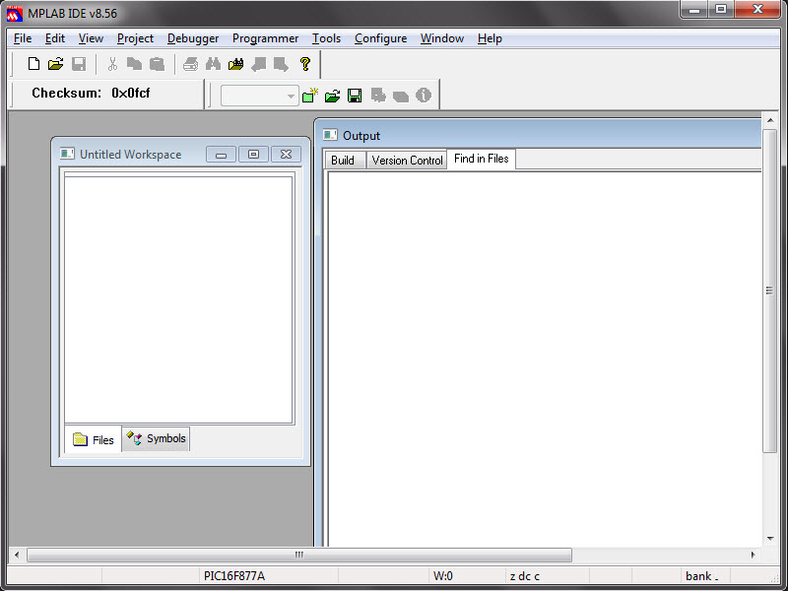

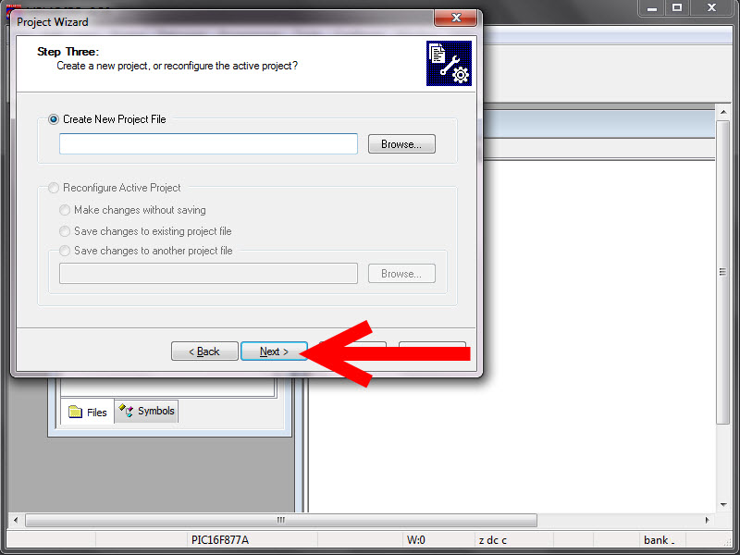

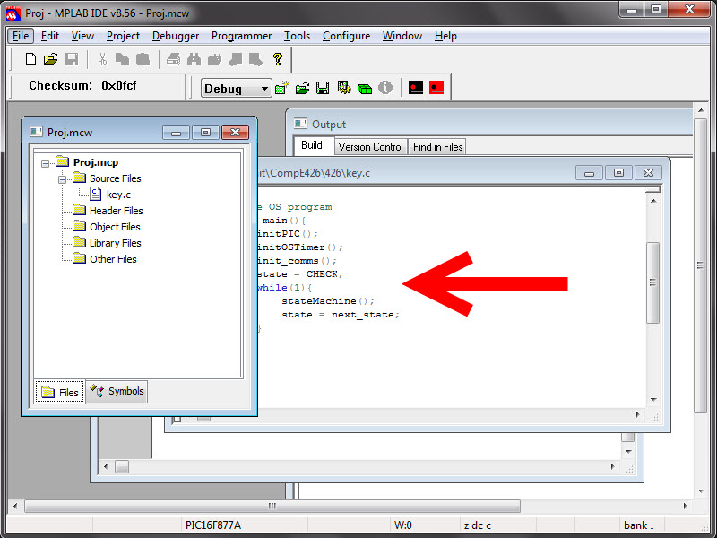

**Programmer:**

**Pic kit 3**

The MPLAB PICkit 3 allows debugging and programming of PIC® and dsPIC® Flash microcontrollers at a most affordable price point using the powerful graphical user interface of the MPLAB Integrated Development Environment (IDE). The MPLAB PICkit 3 is connected to the design engineer's PC using a full speed USB interface and can be connected to the target via an Microchip debug (RJ-11) connector (compatible with MPLAB ICD 2, MPLAB ICD 3 and MPLAB REAL ICE).HID interface, say no more driver again Support windows 7 system USB (Full speed 12 Mbits/s interface to host PC) Real-time execution MPLAB IDE compatible (free copy included)Built-in over-voltage/short circuit monitor  
Firmware upgradeable from PC/web download Totally enclosed Supports low voltage to 2.0 volts (2.0v to 6.0v range) Diagnostic LEDs (power, busy, error) Read/write program and data memory of microcontroller Erase of program memory space with verification Freeze-peripherals at breakpoint Program up to 512K byte flash with the Programmer-to-Go  
Material Plastic Housing Dimensions  
95 x 40 x 13 mm / 3.74 x 1.57 x 0.51 inch  
  
  
  
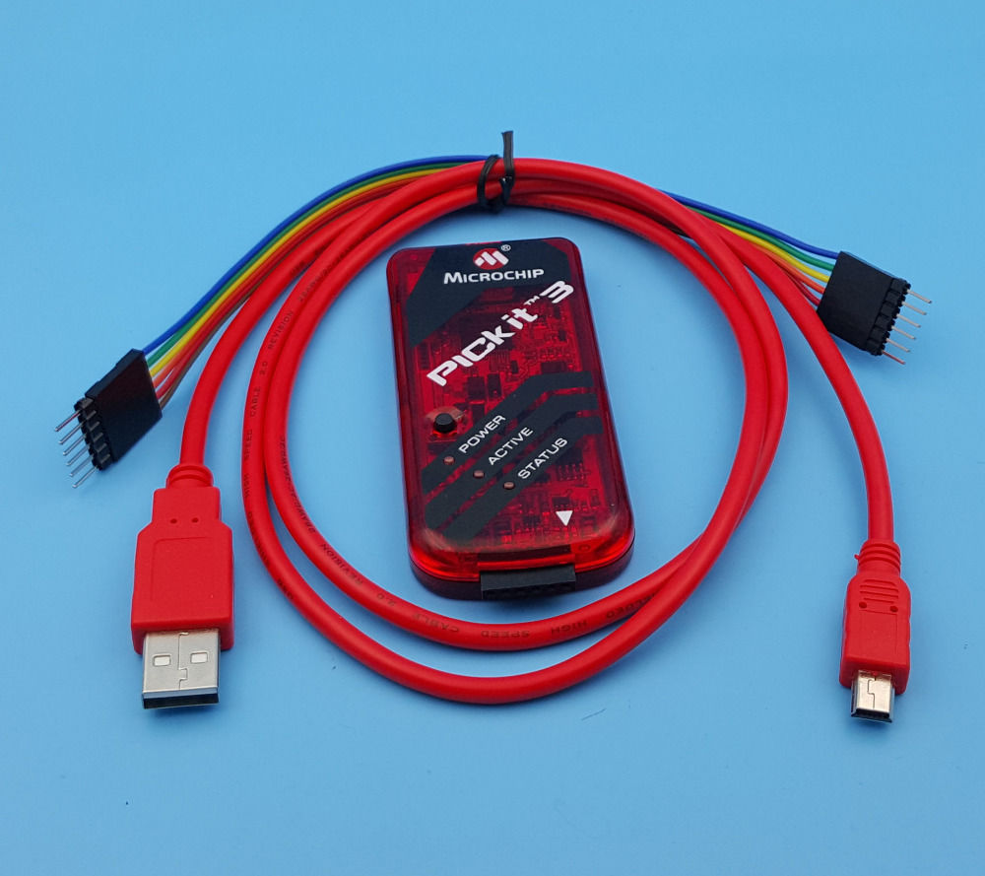

**4.1 Printed Circuit Board (PCB):**

PCB means printed circuit board PCB is one of the most important elements in any electronic system. They accomplish the interconnection the between component mounted on them in particular manner PCB consist of conductive circuit pattern which is applied to one or both sided of an insulating base copper is most widely used for conductor material. Aluminum nickel, silver, brass is used for same special application.

The thickness of conducting material depends upon the current carrying capacity of circuit. Thus a thicker conductor layer will have mare current carrying capacity once the PCB is manufactured the current carrying capacity is depends on which of conductor track.

**FUNCTION: -**

The printed circuit board usually serves there distinct functions are as follows:

* It provides mechanical support for the component mounted on it.
* It provides necessary electrical interconnections.
* It acts as a heat sink i.e. it provides a conduction path leading to removal of most of the heat generate in the circuit.

**Advantage of PCB: -**

Over the conventional wire method:

* PCB’s have controllable and predicable electrical mechanical properties.
* Rapid production is possible.
* Time is saved since it avoids wiring connections production to another
* Weight is reduced.
* Soldering is done in one operation instead of individual connection between component and wires.
* Cost is less.

**TYPES OF PCB:**

* Single sided PCB.
* Double sided PCB.
* **Single Sided PCB: -**

This type of PCB consists of a natural coil of a copper on only one side of the base material. This type of PCB frequently used when the manufacturing cost has to be kept at minimum.

* **Double Sided PCB: -**

Double sided PCB is used when there is more number of jumpers. This type of PCB has copper fail on both side of base material. The double-sided PCB’s are used when insulation of PCB is very complicated i.e. if jumpers are more in number and when it is difficult to fabricants the PCB ON a single sided PCB.

The various steps involved in PCB.

Preparations are:

* **Layout planning**
* **Artwork drawing**
* **Artwork transforming**
* **Painting**
* **Etching**
* **Drilling**
* **Soldering**
* **Mounting of component**
* **Testing**
* **Protection**
* **ADVANTAGE:**

The most important advantage of this system is to make the system independent of on-board processing which uses most of the battery power as well as the independency of each module makes it easier for upgrade to new feature. The wireless feature makes it useful to work from a distant location with virtually controlling.